Feasibility Report

**Android Based APP For Crime Reporting**



**Project By**

Sabtain Tanvir FA14-BSE-090

Asad Zeb FA14-BSE-111

Adeel Ahmad FA14-BSE-114

**Supervised by**

Sir Sarmad Jadoon

**Table of Content**

1. Title: "Title of the project" 3

2. Functional Requirements: 3

3. Proposed tools: 3

4. Feasibility Analysis: 3

4.1. Technical Feasibility: 4

4.2. Financial Feasibility: 4

4.3. Resource Feasibility: 5

4.4. Schedule: 5

4.5. Operational Feasibility: 5

5. Assumptions: 5

1. Title: "Android Based Mobile App For Crime Reporting"
2. Functional Requirements:

* The system can report subjected crimes.
* Online FIR
* Admin will be able to control access rights and assign different roles.
* Geo location of the crime scene will be accessed by google map API
* The System will notify the user.
* System will be alerted if any report is generated
* it’ll control multiple alerts if generated from same location

1. Proposed Tools

* Programming Language
  + Java
  + HTML5/CSS
  + PHP
* Platform
  + Android, web
* Tool
  + Android Studio
  + Adobe Dreamweaver
* Application Programmable Interface
  + Google Map API

1. Feasibility Analysis:

An overall study of the project has been carried out and the findings have been listed in this report. The feasibility of **“Android Based App For Crime Reporting”** can be ascertained on the following assessments:

* Technical feasibility
* Financial feasibility
* Resources feasibility
* Schedule feasibility
* Operational feasibility
  1. Technical Feasibility:
* Google Map API
* Java
* XAMP Server
* HTML5,CSS,PHP
  1. Financial Feasibility:

Feasibility of financial aspects e.g. pricing and source of availability and financing of tools and other resources required for the project are tabulated below:

|  |  |  |
| --- | --- | --- |
| **Resource Name**  **[hardware or software]** | **Price**  [Monetary cost] | **Source**  [website URL/Dealer's address etc.] |
| Andriod Studio | Free | https://developer.android.com/studio/index.html#win-bundle |
| Adobe **Dreamweaver** |  | http://www.adobe.com/products/dreamweaver.html |
| Google Maps API | Free | https://developers.google.com/maps/documentation/android-api/start |
| Laptop | 40000 | Self |
| Web Domain and Hosting | Rs. 2,500 | Arvixe.com |
| SmartPhone | 12000 | Already Owned |
| Sponsors/ Funding src | Self | |

* 1. Resource Feasibility:

|  |  |  |
| --- | --- | --- |
| **S.No** | **Resources** | **Availability** |
| 1 | Developing team | yes |
| 2 | Software | yes |
| 3 | Smartphone/Laptop | yes |

* 1. Schedule feasibility:

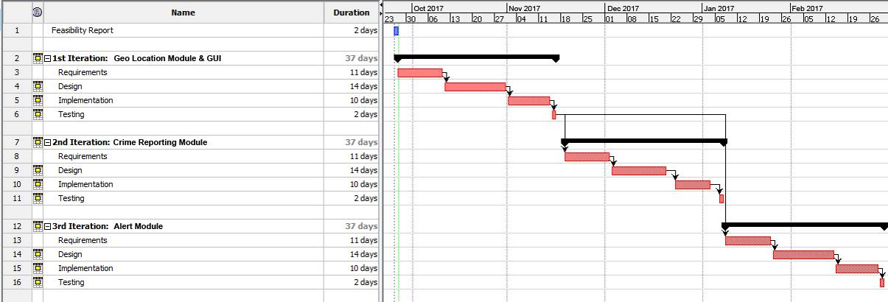

* 1. Operational Feasibility:
* To make our web server operational we will use a free hosting website.
* Internet connectivity is mandatory.

1. Assumptions:

This Android Based App For Crime Reporting will work with WiFi/GPS, 3G/4G technology.